**CSE 498 NLP Project 2 Report**

**Zhiheng Liu**

**Part 1: Answer of the exercises:**

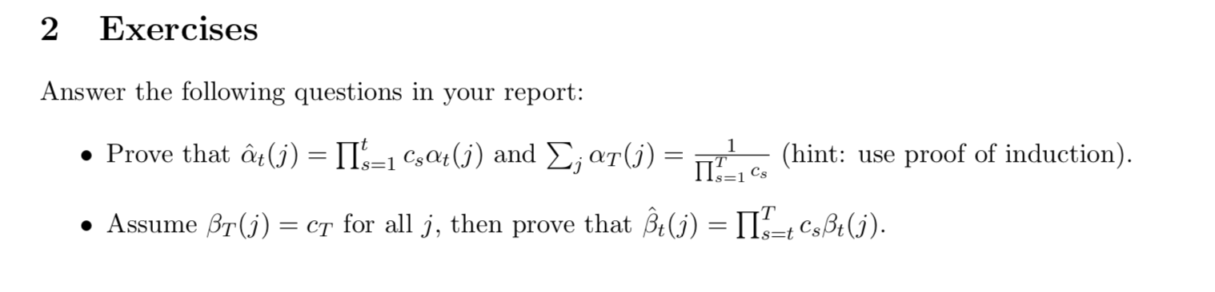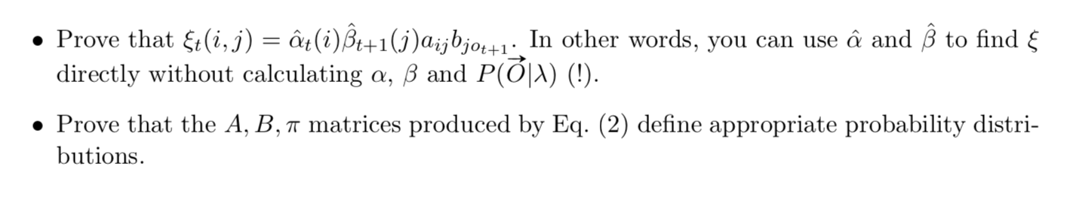

**Answer:**

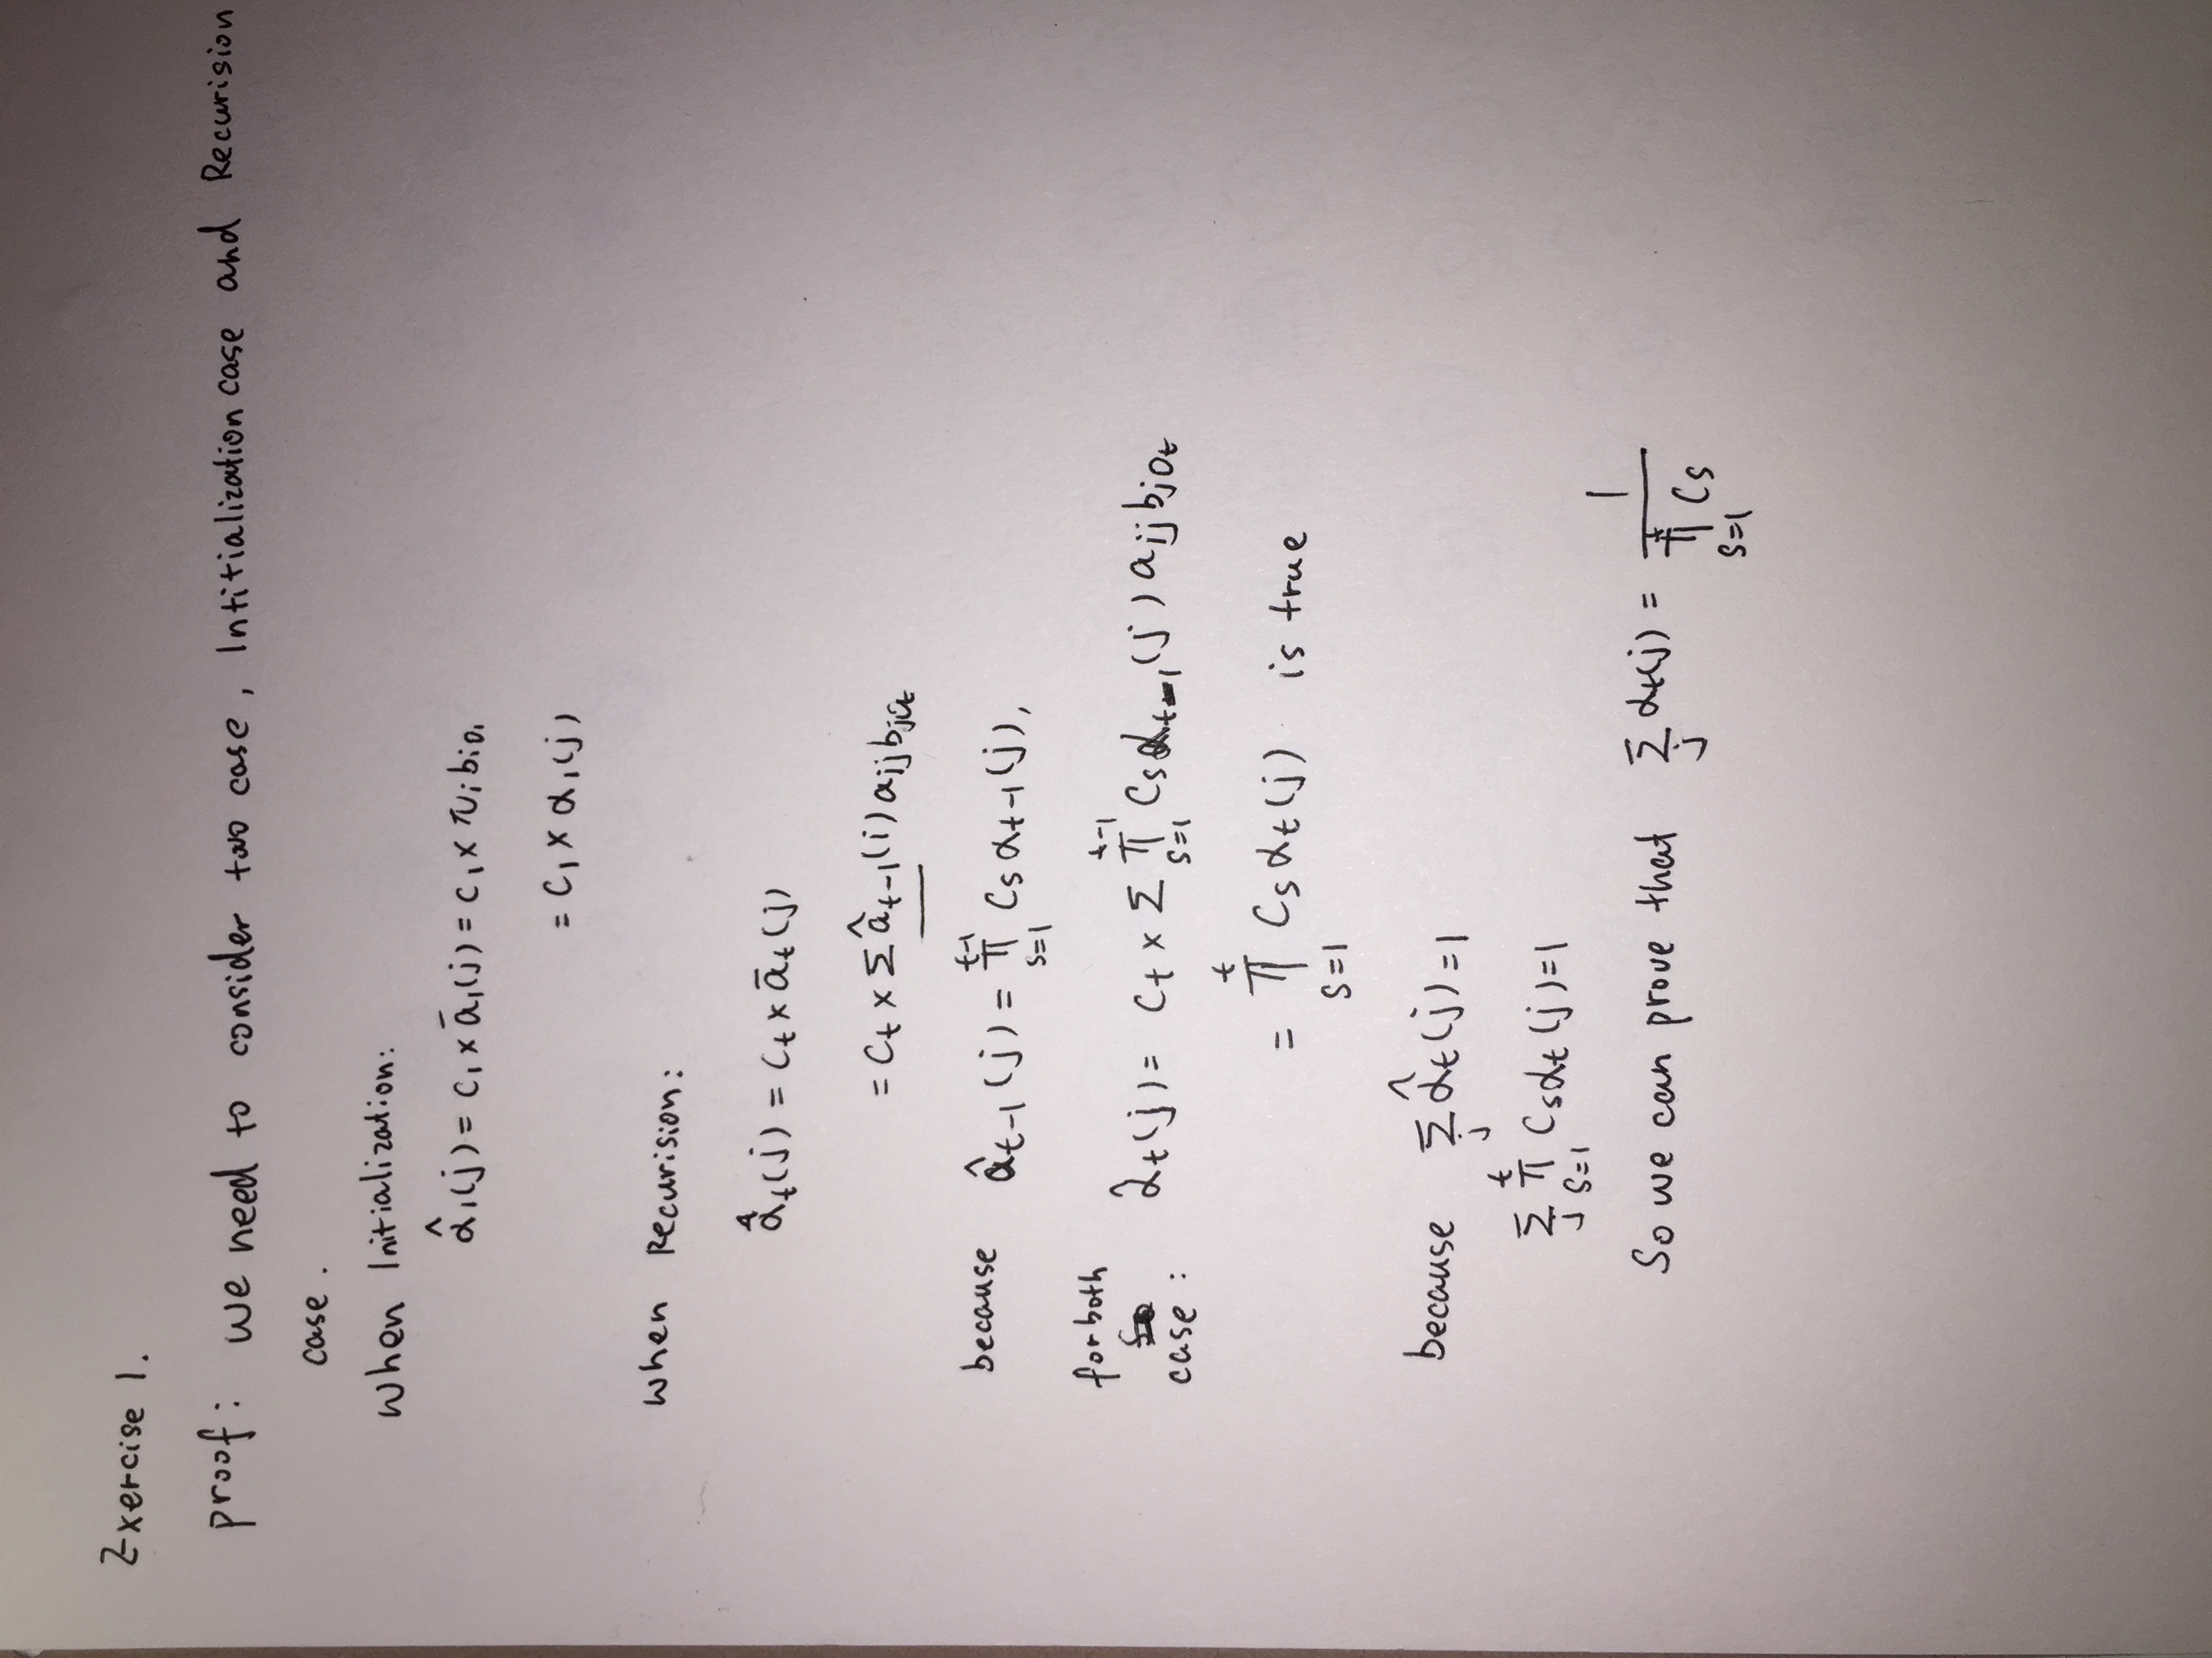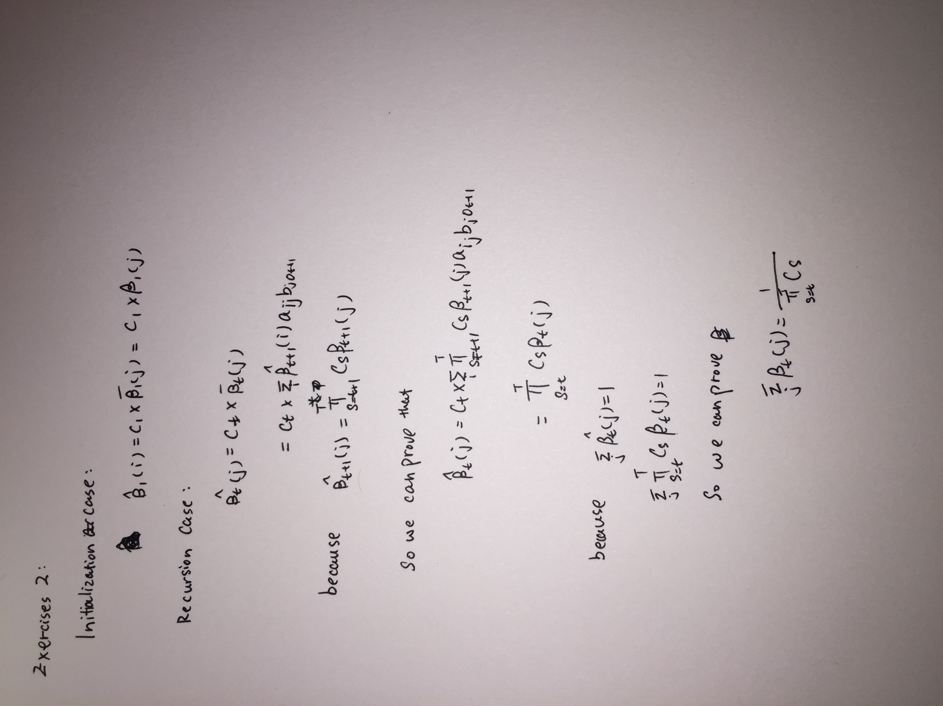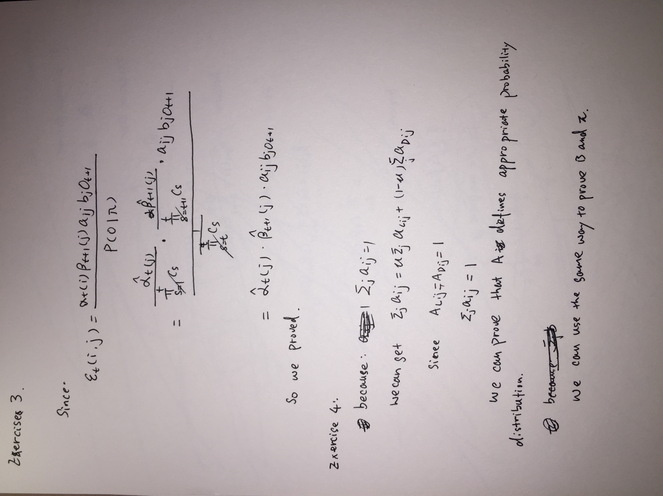

**Part 2 HMM experiment**

**Without concatenation:**

**Log-likelihood performance: (mu 0.0 – 1.0)**

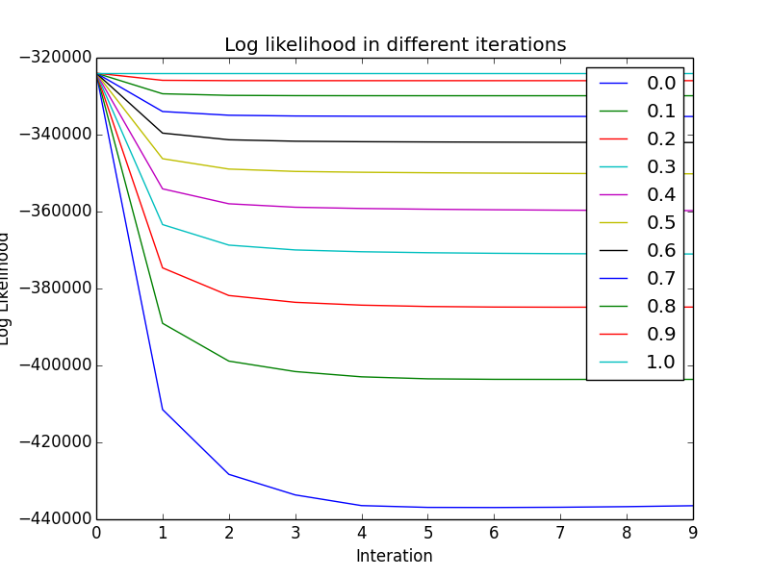

**Part 3 Readme.txt**

**Please check the readme file in the folder, thank you!.**